******************************************

Roll.no:20UIT021

Name: R.SRIDEVI

Ex.No:1.2

Program name:Capture package using wireshark

Date:20.07.2022

*******************************************

**1.Open the terminal:**

[itstudent@a4it109 ~]$ su

Password:

[root@a4it109 itstudent]# wireshark

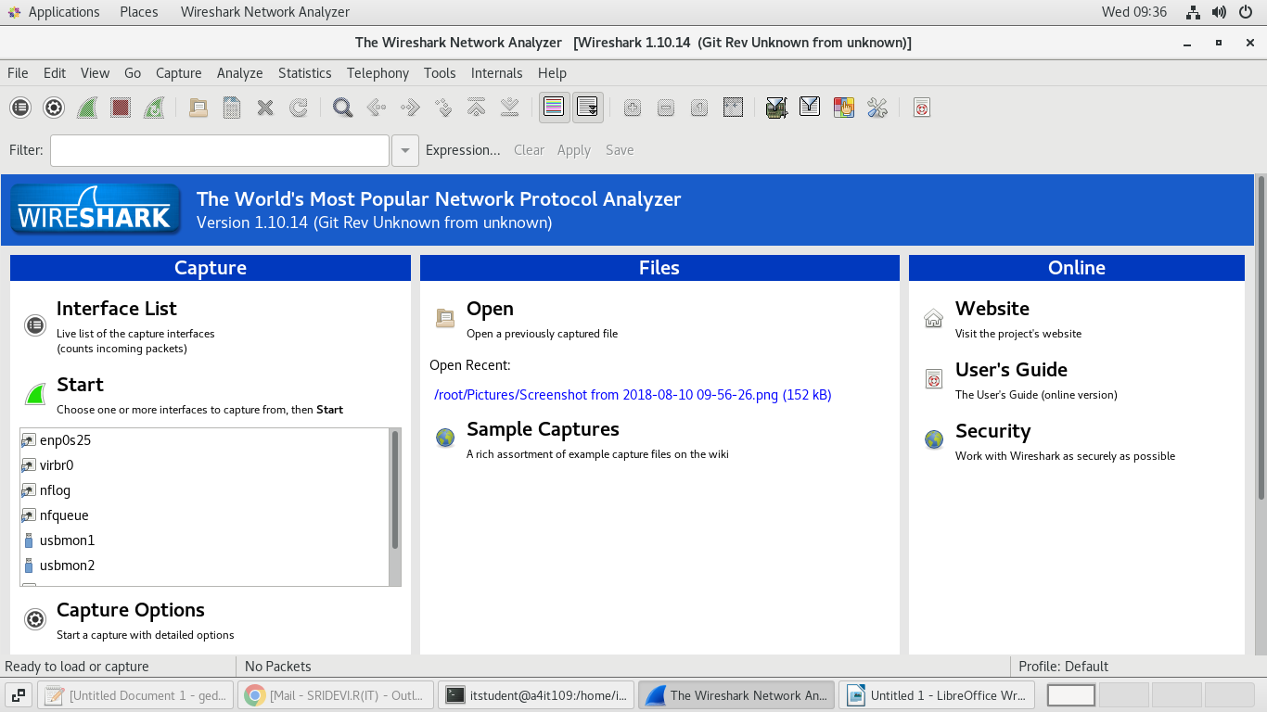

**2.List of interfaces:**

**capture → interface**

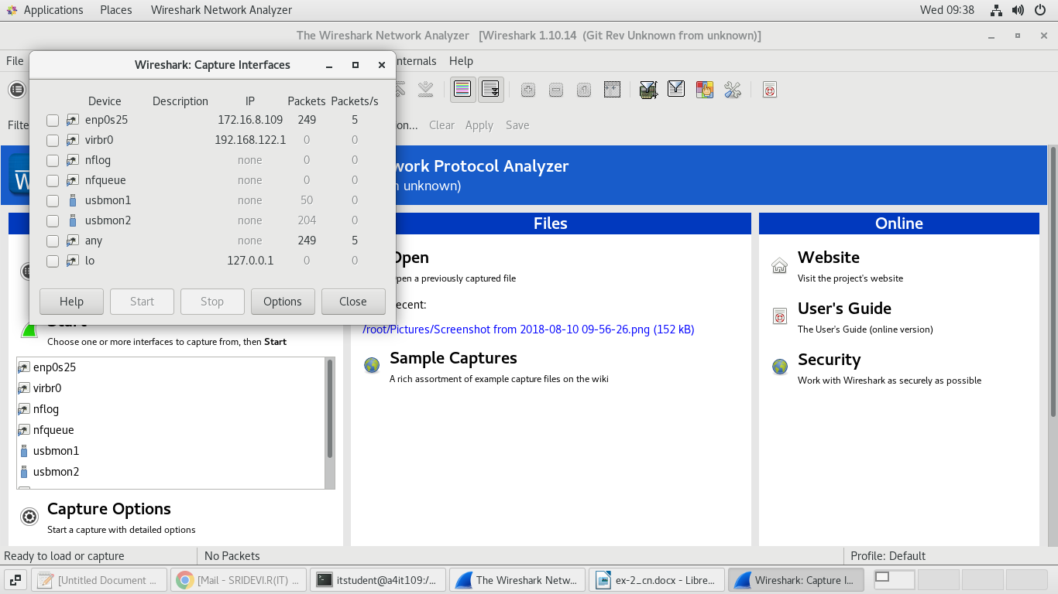

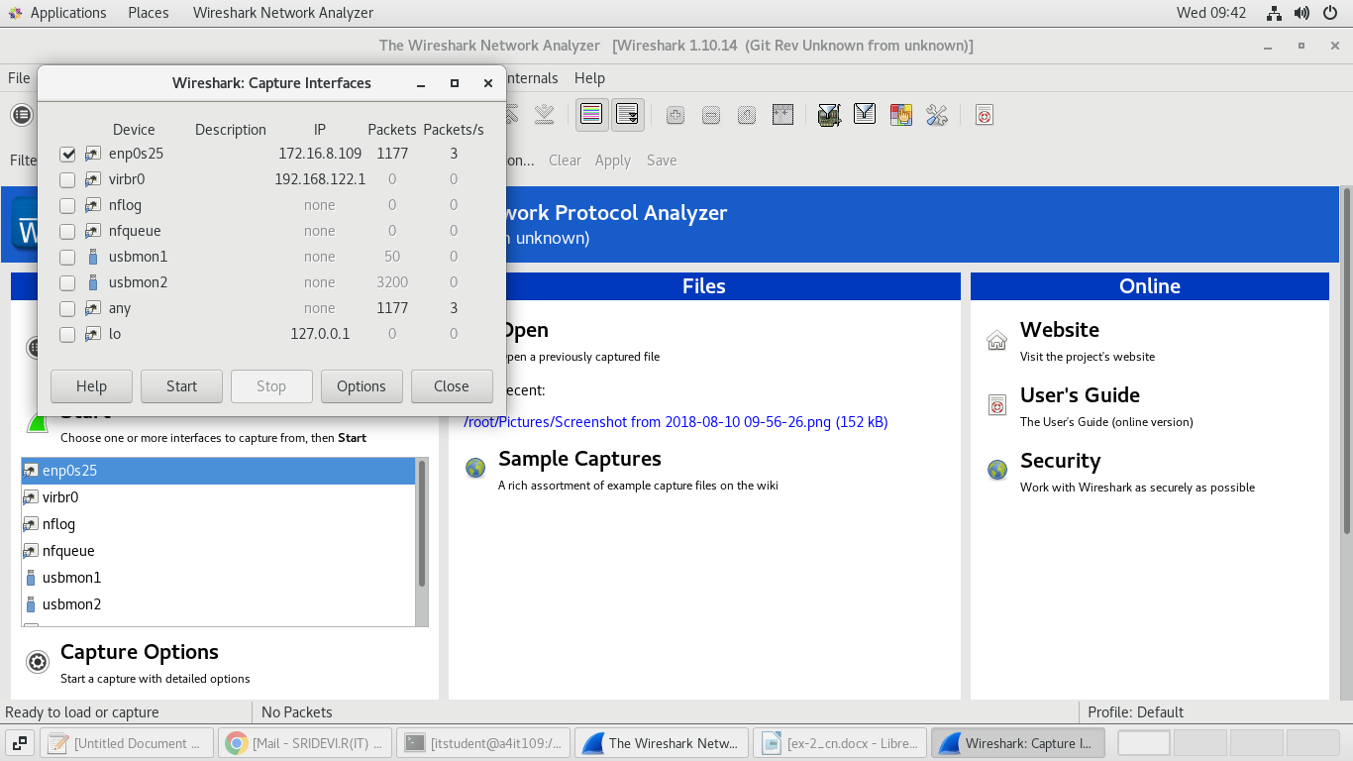

**3.Caputer packet:**

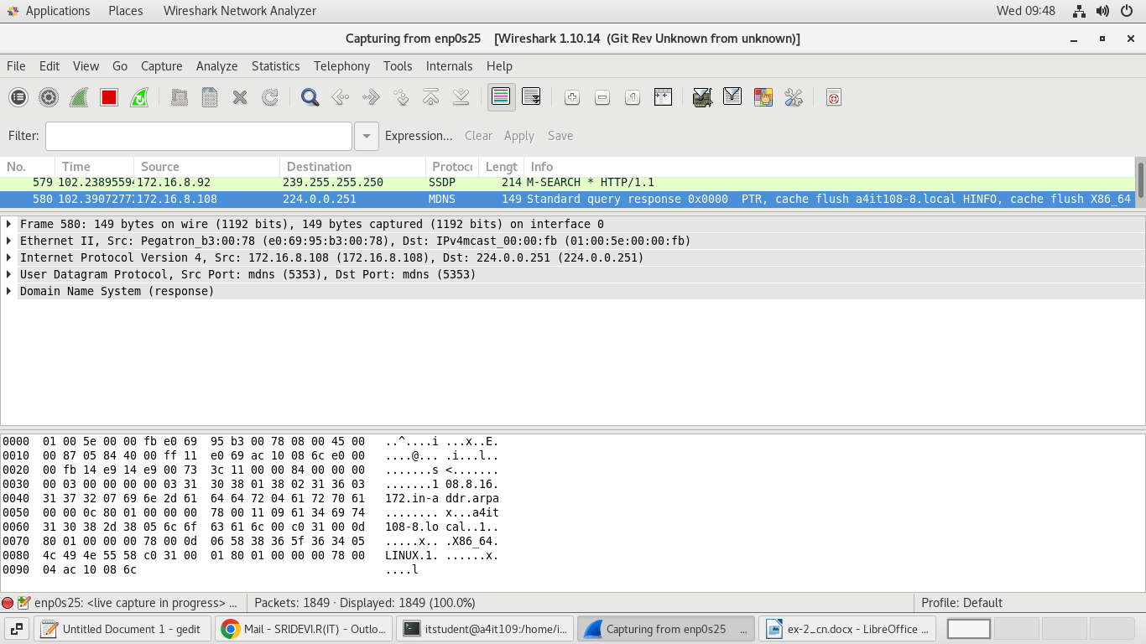

**4.Another way to capture the packet:**

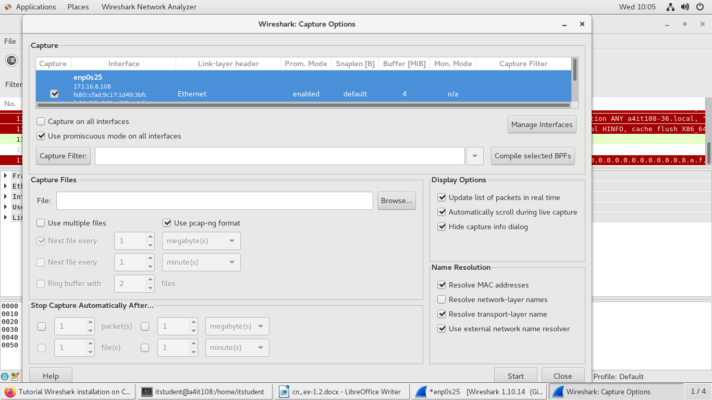

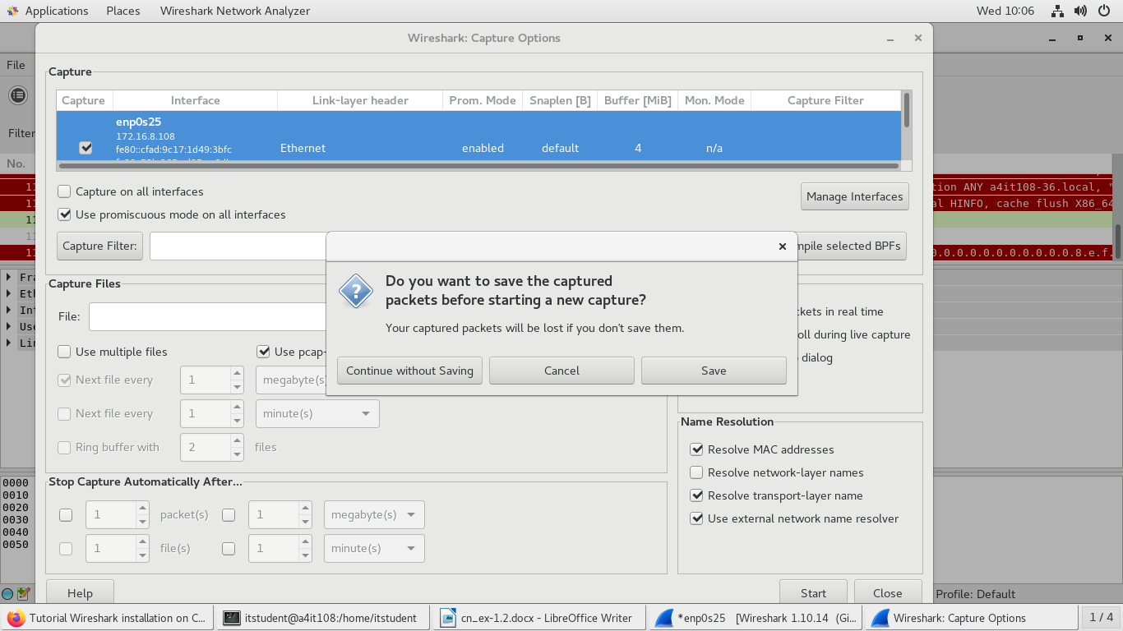

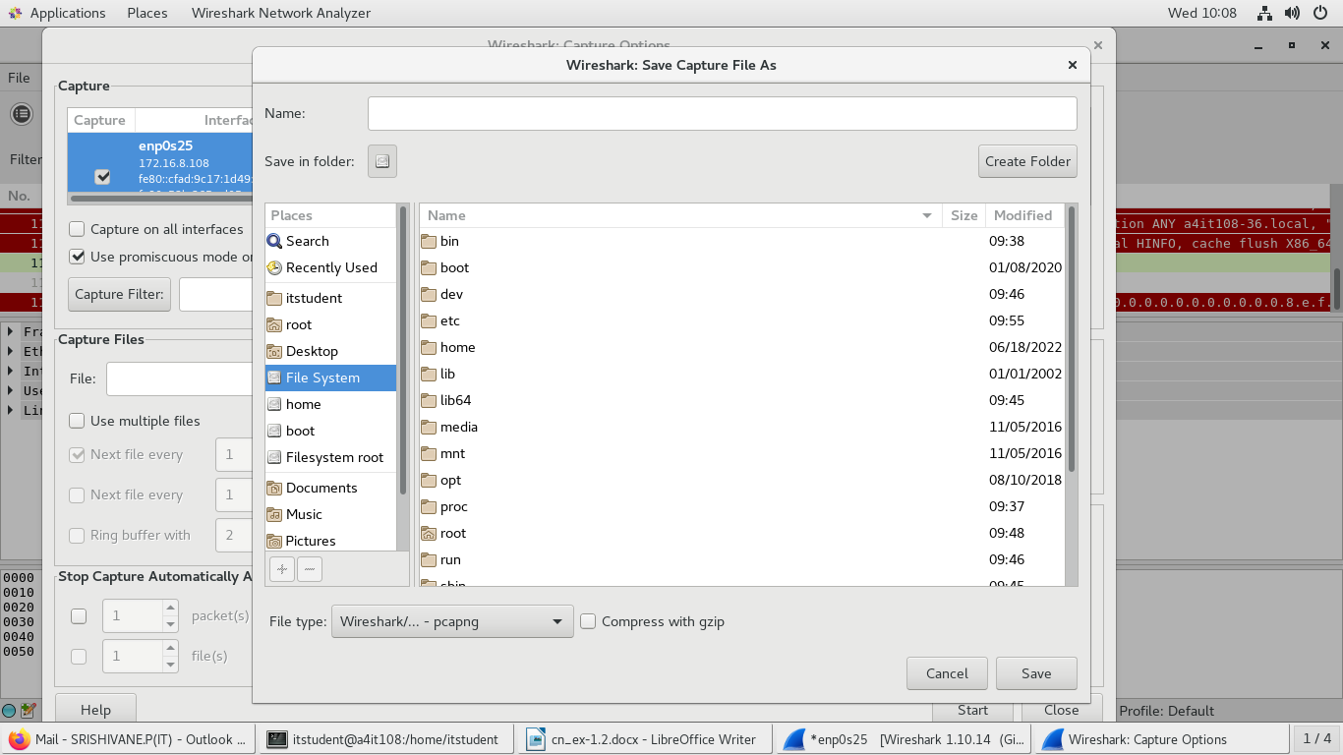

**5.Filtering packets**

**Analyse->Display filters**

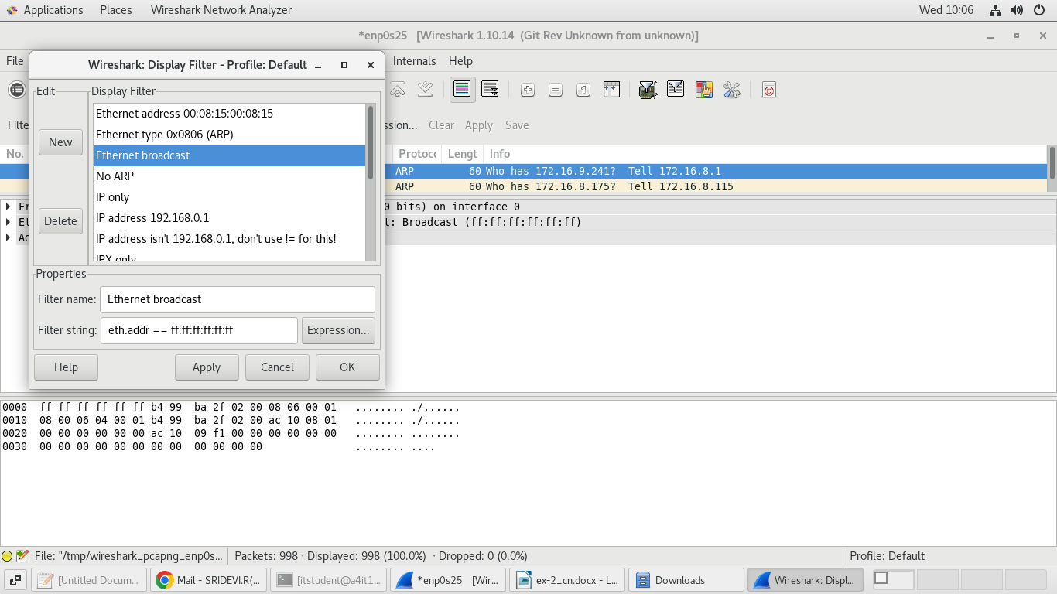

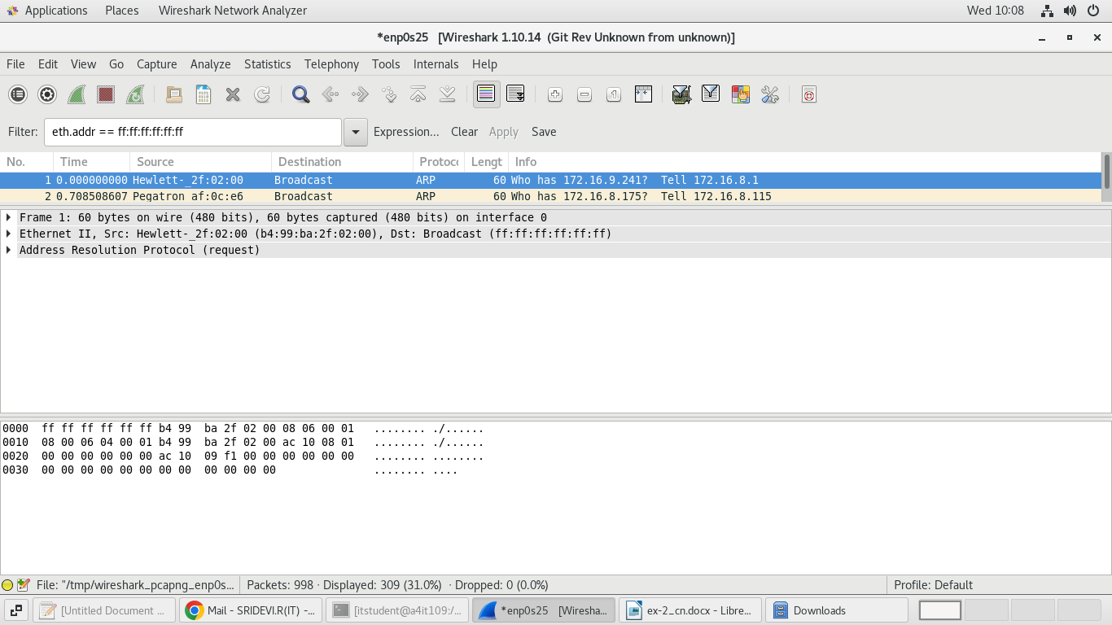

**6.To view the Summary**

**Statics → Summary**

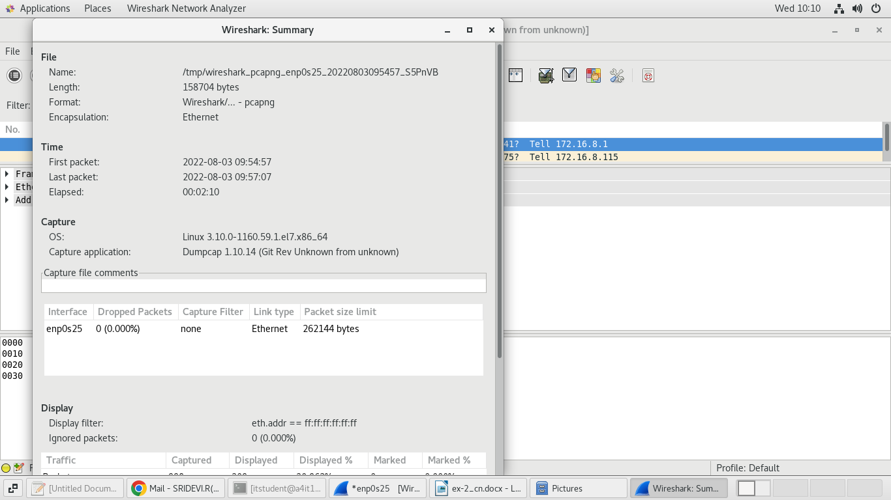

Summary created by Wireshark (Git Rev Unknown from unknown)

File:

Name: /tmp/wireshark_pcapng_enp0s25_20220803095457_S5PnVB

Length: 158704 bytes

Format: Wireshark/... - pcapng

Encapsulation: Ethernet

Time:

First packet: First packet:

Last packet: Last packet:

Elapsed: Elapsed: et: Last packet: ast

Capture:

OS: Linux 3.10.0-1160.59.1.el7.x86_64

Capture application: Dumpcap 1.10.14 (Git Rev Unknown from unknown)

enp0s25:

Dropped packets: 0 (0.000%)

Capture filter: none

Link type: Ethernet

Packet size limit 262144 bytes

Statistics:

Packets: 998

Between first and last packet:130.016 sec

Avg. packets/sec: 7.676

Avg packet size: 125.784 bytes

Bytes: 125532

Avg bytes/sec: 965.512

Avg Mbit/sec: 0.008

**7.To view the details of IP using arp:**

**Statistics → show address resolution**

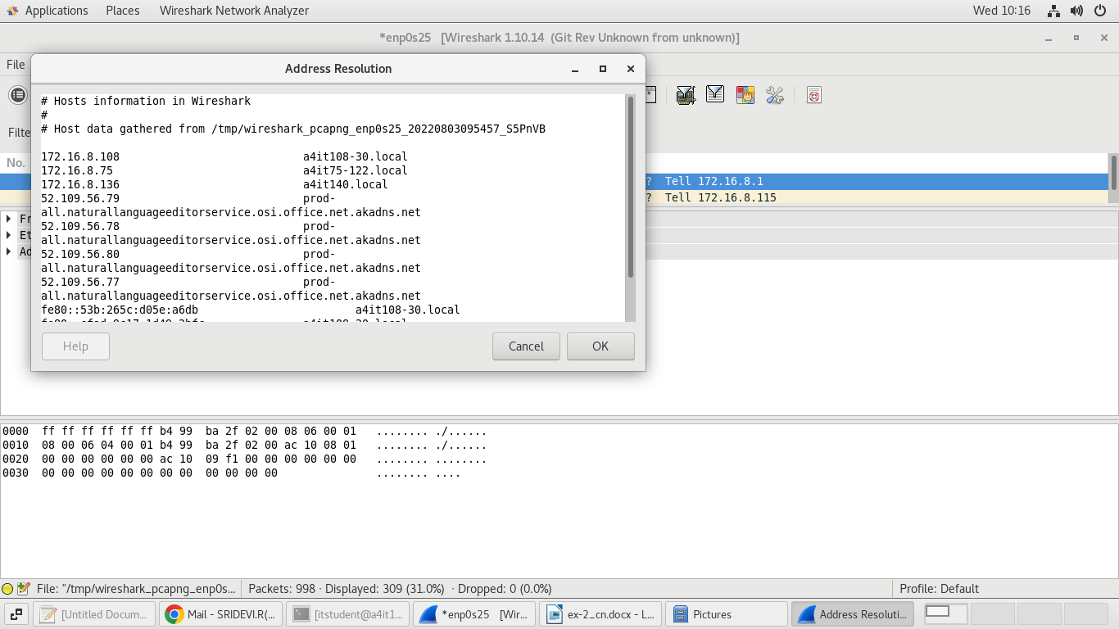

**8.To view the protocol hierarchy**

**Statistics → Hierarchy**

